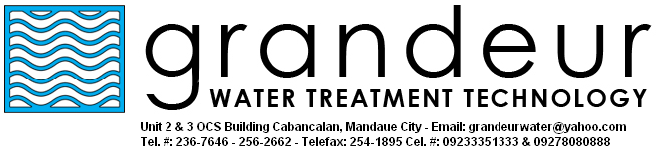

COMPANY PROFILE

HUMBLE BEGINNINGS

From a very small company which started January 2003, Grandeur Water Treatment Technology catered to clients within Cebu City in terms of supplying quality water treatment facilities, consumables and services. After years of providing great service to numerous clients, GWTT is expanding rapidly and now gratifying not only Cebu City clients but clients outside the province as well. GWTT is outfitted with manpower and equipments that perfects water treatment. The company is fast growing and aspiring to be one of the overall leaders of providing water treatment facilities in the country.

CORPORATE VALUES

- We situate God on top of everything
- We deem that the client is the boss
- We value our manpower as our best asset
- We provide excellent service
- We pursue originality and innovation

CORPORATE VISION

- To be the most respected water treatment technology provider in the country.
- To be a competent partner to our growing list of clientele.
CORPORATE MISSION

In these time of harsh competition, businesses, big and small, are looking for ways to save money for the purpose of being more competitive in their respected fields. Grandeur Water Treatment Technology’s mission is to support these businesses by providing excellent service at the lowest possible cost, and by providing equipments that are durable and cost-effective. We are confident that our technical know-how in the water treatment business will be an X factor to our growing list of satisfied clienteles. This growing list of satisfied clienteles is also proof of our dedication and passion towards our craft. And we hope, as we move forward, that our tireless dedication and unyielding passion will be the very reason that will make Grandeur Water Treatment Technology a champion among its competitors.

